Chapter 17, Solution 54.

T = 4, ω_{o} = 2π/T = π/2

c_{n} = 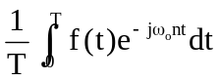

= 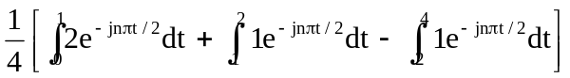

= 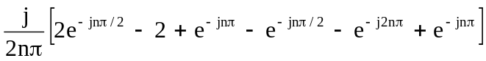

= 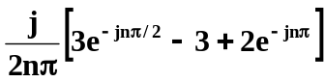

f(t) = 